



adges UI components library

**Component ID #1 – ex-formcalculation - v1.1.0**

## Document Control

## Version History

|  |  |  |  |
| --- | --- | --- | --- |
| Version | Date | Author | Reason for Change |
| 1.0.0 | 4/16/2020 | Wael Gomaa |  |
| 1.1.0 | 23/09/2020 | Rijin Mukundan |  |
|  |  |  |  |
|  |  |  |  |
|  |  |  |  |
|  |  |  |  |
|  |  |  |  |
|  |  |  |  |

## Review History

|  |  |  |
| --- | --- | --- |
| Version | Reviewer | Date |
|  |  |  |
|  |  |  |
|  |  |  |
|  |  |  |
|  |  |  |
|  |  |  |
|  |  |  |

Table of Contents

Document Control 1

Version History 1

Review History 1

1. Document and components Purpose. 3

2. General Information. 3

3. How to use. 3

4. Component features and configure. 4

5. How to configure component. 4

6. Examples 4

# 

# Document and components Purpose.

The purpose of the document is to guide how use and configure **ex-formcalculation** component.

# General Information.

Component Name: Form Calculation.

Extension Theme: ex-formcalculation.

Owner: .

Version no: v1.1.0

Design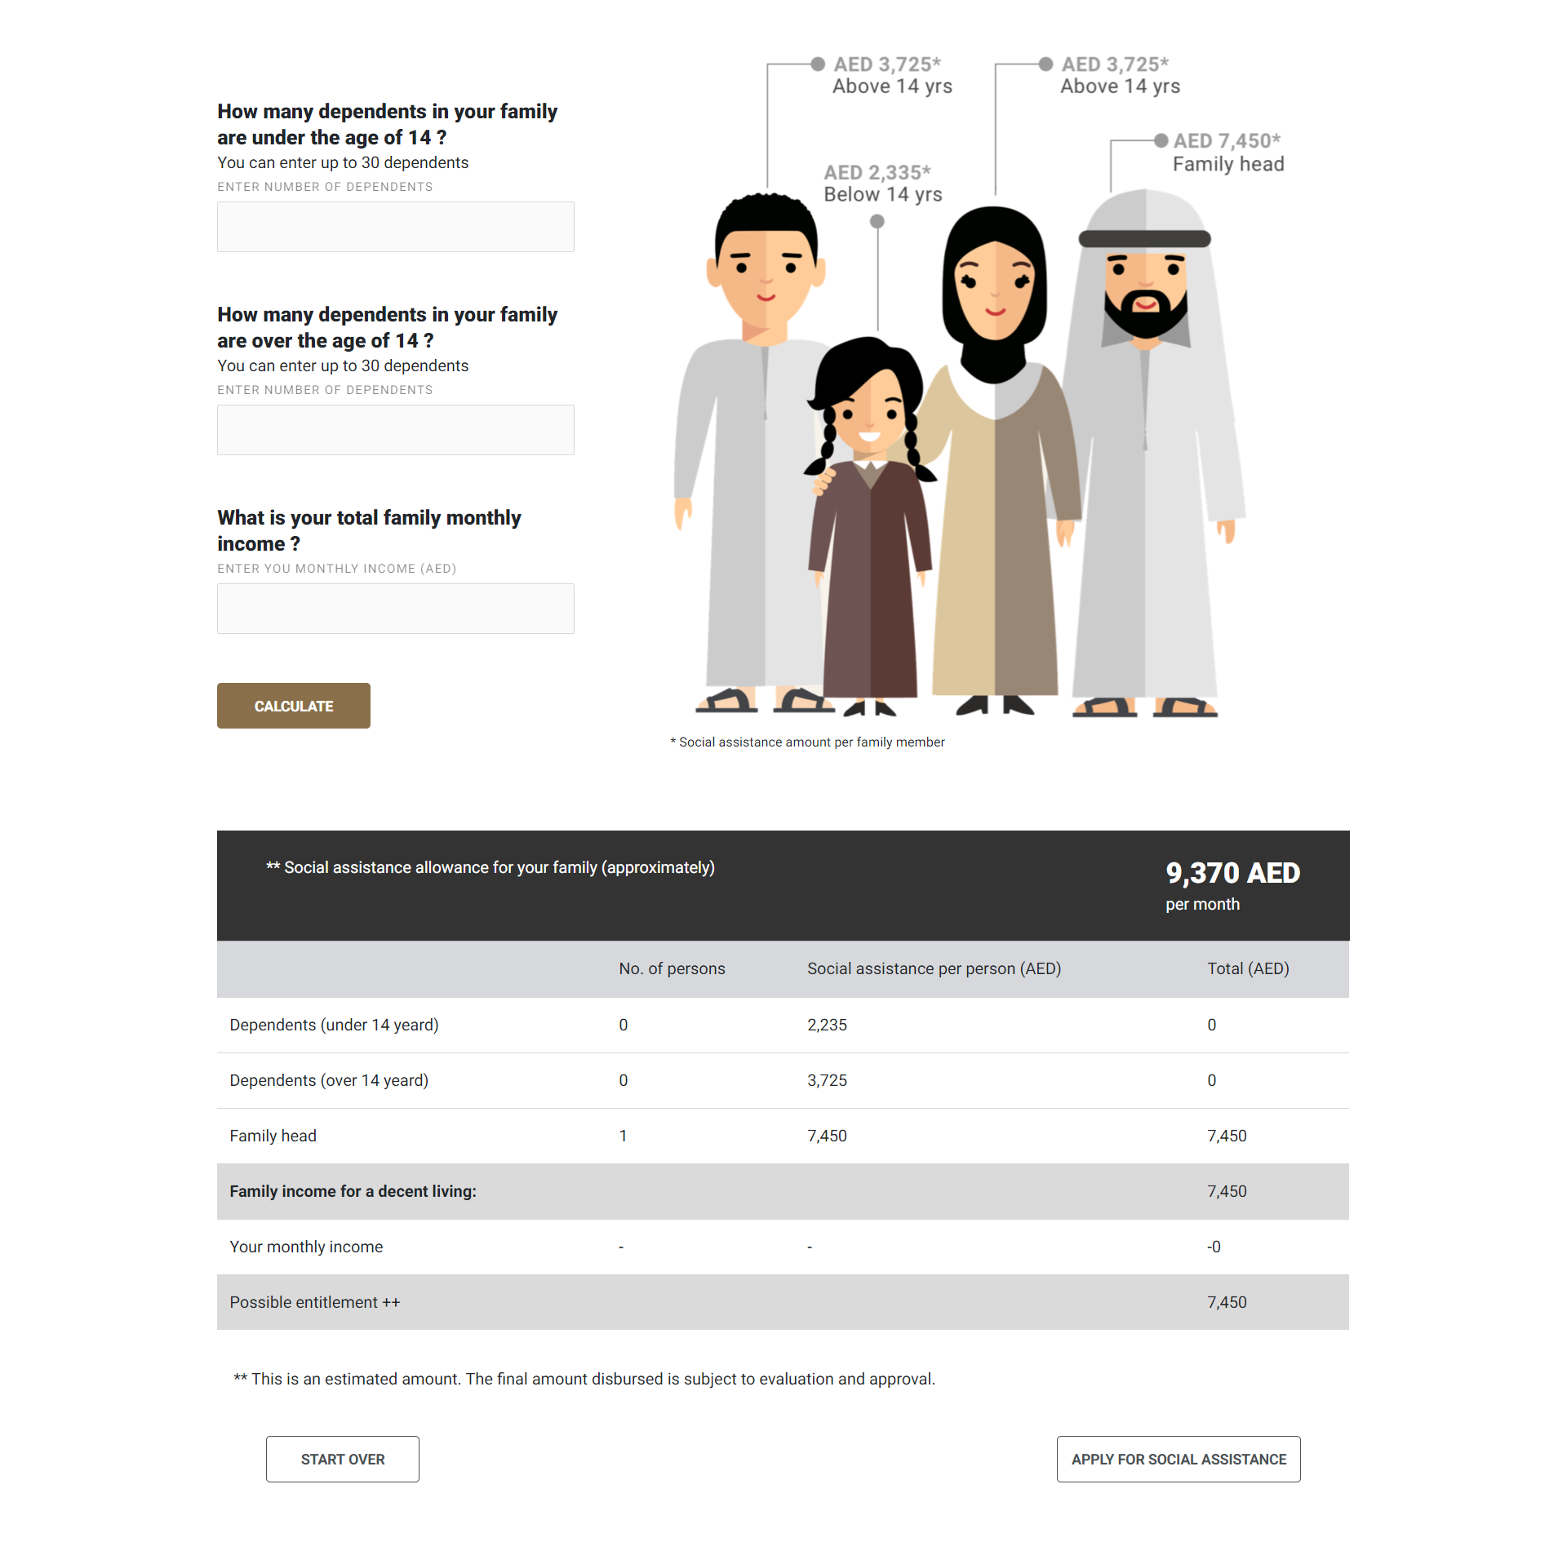

# How to use.

1. The available commands for this project .
   1. Compile : npm run gulp compile -- –path ex-formcalculation –extension
   2. Compile & include under ADGE tenant : npm run gulp compile -- –path ex-formcalculation –extension –full –dest [ADGEFolder]
   3. Deploy : npm run gulp deploy -- –path ex-formcalculation –extension
2. *Now project have full copy from this extension theme under the project theme and you can apply the project brand guideline and configure component based on project needs.*

# Component features and configure.

You have access now to configure component with the below item.

$formcalculation-table-header-color : $white-color !default ;

$formcalculation-table-header-bg : $grey-600 !default ;

$formcalculation-table-head-bg : $grey-100 !default ;

$formcalculation-table-active-bg : $grey-200 !default ;

$formcalculation-table-active-fw: bold !default;

$formcalculation-button-bg : $primary-color !default ;

$formcalculation-button-color : $primary-color4 !default ;

$formcalculation-button-fs : 16px !default ;

$formcalculation-table-lh: 30px !default ;

$formcalculation-buttons-border-width : 2px !default;

# How to configure component.

There are various ways to configure the component:

1. **Adding Built-In or Bootstrap Class (on the variant)**
   1. Spaces, Font weights, Display, Position properties etc can be added by bootstrap classes
      1. i. Spacing: <https://getbootstrap.com/docs/4.0/utilities/spacing/>
      2. ii. Flex: <https://getbootstrap.com/docs/4.4/utilities/flex/>
      3. iii. Font: <https://getbootstrap.com/docs/4.0/content/typography/>
   2. These classes should only be added to match the design
   3. For built-in classes check 7 Below to see the entire list
2. **SCSS Variable Override (on the _override.scss file)**

To configure the component we can take the above variables from section **4. Component features and configure** and add them to: adge-ph2/themes/<ADGE>/vars/_override.scss, this file with your desired changes to match the design.

1. **Complete style override**
   1. This should be the last and final option if the above 3 didn’t get you the desired output
   2. This is overwriting the SCSS of the component by adding your own style to it
   3. **Note: Take permission before doing this override**
   4. Instructions:
      1. Open the file /adge-ph2/themes/<ADGE>/sass/overrides.scss and add your own SCSS styles to override the faulty component.

# Dependencies

components-formcalculation.css

components-sitecore-form.css

components-formcalculation.js

# Examples

Examples1:

I need to change text color.

I’ll copy the below variables from extension theme.

$highlight-main-tittle-color: $primary-color;

Then will paste the above variable in project folder theme in file _custom.scss and change with any variable based on site needs.

$highlight-main-tittle-color: $secondary-color;

Examples2:

I need to the button shape from square to had a rounded corner.  
I’ll copy the below variables from extension theme.

$button-shape-square: $border-radius-value;

$border-radius-value: 0px;

Then will paste the a above variable in project folder theme in file _custom.scss and change with any variable based on site needs.

$button-shape-square: $border-radius-value;

$border-radius-value: 20px;